, 

Subject:
Practical Machine Learning
ECE 590.11.Fa25

Astrophotography Capture:
Error Classification

Prepared For:
Xiang Cheng

Prepared By:
Ananya Singh
Astha Sul
Tim Force
Vinodhini Rajasekhar
1 Executive Summary: 4
2 Literature Review: 4
3 Baseline Experiment Design: 6
3.1 Dataset Acquisition and Management 6
3.2 Preprocessing Pipeline 6
3.3 Model Architecture 6
3.4 Training and Evaluation 6
4 Preliminary Results: 7
4.1 Data Preprocessing 7
4.2 Training data extraction 9
4.3 Model testing 12
5 Notable Observations: 21
6 Conclusion and Future Direction: 22
7 References: 23

Figure 4-1 Before DeBayer process 8
Figure 4-2 After DeBayer process 8
Figure 4-3 DeBayered and Stretched 8
Figure 4-4 256x256 Color Training Image 8
Figure 4-5 DAOStarFinder Results 10
Figure 4-6 DAOStarFinder Locations 10
Figure 4-7 Star extraction using YOLO 10
Figure 4-8 Extraction using MSER and NMS extracting regions in nebula 11
Figure 4-9 Cropped images of stars 11
Figure 4-10 Multi-Model results table 13
Figure 4-11 Pre-Trained ResNet-18 Loss 14
Figure 4-12 Pre-Trained ResNet-18 Accy 14
Figure 4-13 Scratch ResNet-18 Loss 14
Figure 4-14 Scratch ResNet-18 Accy 14
Figure 4-15 ResNet-18 Performance after Dataset Balance 14
Figure 4-16 Pre-Trained MobileNetV2 Loss 15
Figure 4-17 Scratch MobileNetV2 Loss 15
Figure 4-18 Pre-Trained MobileNetV2 Accy 15
Figure 4-19 Scratch MobileNetV2 Accy 15
Figure 4-20 MobileNetV2 Performance after Dataset Balance 16
Figure 4-21 Scratch ShuffleNetV2 Loss 16
Figure 4-22 Scratch ShuffleNetV2 Accy 16
Figure 4-23 ShuffleNetV2 Performance after Dataset Balance 17
Figure 4-24 Scratch DenseNet-121 Loss 17
Figure 4-25 Scratch DenseNet-121 Accy 17
Figure 4-26 DenseNet-121 Performance after Dataset Balance 18
Figure 4-27 Scratch GoogLeNet Loss 18
Figure 4-28 Scratch GoogLeNet Accy 18
Figure 4-29 GoogLeNet Performance after Dataset Balance 19
Figure 4-30 Scratch EfficentNetV2 Loss 19
Figure 4-31 Scratch EfficentNetV2 Accy 19
Figure 4-32 EfficentNetV2 Performance after Dataset Balance 20
Figure 4-33 Scratch VGG16_BN Loss 20
Figure 4-34 Scratch VGG16_BN Accy 20
Figure 4-35 VGG16_BN Performance after Dataset Balance 21

Executive Summary:
Astrophotography involves capturing hundreds of long-exposure frames that are later stacked to form a final image. Still, many of the frames are compromised by issues during capture, such as poor focus, tracking/guiding, wind/weather, and excess light exposure. Currently, identifying good vs bad frames is a manual, subjective, and time-consuming process. This often results in inconsistent quality and wasted time. Without an automated system for error detection and classification, valuable observation time, data quality, and imaging precision are lost. The proposed methodology is to automate the process and significantly enhance the efficiency, consistency, and overall output quality in astrophotography.

Literature Review:
Teimoorinia et al. (2020) [1] present a machine learning framework for automated quality assessment of wide-field astronomical images from the CFHT MegaCam survey. Their method combines an unsupervised self-organizing map with a supervised convolutional neural network to classify exposures into five quality categories. The pipeline begins by clustering millions of Source Extractor detections into a 15 × 15 self-organizing map that is further grouped into twenty clusters. From each cluster, a representative 25 × 25 pixel cutout is extracted and combined into a single composite “representative image”. Along with this image, the population histogram of cluster memberships is provided as an auxiliary input to the classifier. Their model achieves about 97 percent consistency with human classification and shows that classical metrics such as FWHM and ellipticity can fail to identify a significant fraction of problematic images.
This work adds meaningful value to our project because it demonstrates that star-based machine learning approaches can reliably identify imaging artefacts that traditional heuristics miss. It also validates the idea that high-level decisions about image quality can be made from compact subsets of stellar cutouts rather than full survey frames. The structure of their classes aligns closely with ours, since both studies focus on detecting features such as tracking issues, background problems and shape distortions that are visible in the stars themselves.
Despite these similarities, our approach advances beyond several limitations of the Teimoorinia framework. Their model operates at the exposure level and depends heavily on Source Extractor parameters and the specific tuning of the self-organizing map. By contrast, we work directly with standardized monochrome cutouts of individual stars and train modern convolutional networks end-to-end using only pixel information. This reduces reliance on catalog measurements and makes our approach more portable across instruments. Their quality categories are intentionally broad, merging different failure modes together. Our labels isolate specific star shape distortions such as focus, tracking drift and wind shake, which allows for finer diagnostic value and more targeted feedback for observers. Finally, while their method compresses information through a fixed clustering scheme, our pipeline extracts high quality regions of interest using domain-specific algorithms such as DAOStarFinder, which preserves true stellar structure and produces more consistent inputs for the classifier. Together, these improvements position our work as a more flexible, higher resolution extension of the quality assessment idea introduced by Teimoorinia et al.
Work by Li et al. [2] presents AQSA-Net, a lightweight deep-learning model designed for rapid, real-time astronomical image quality assessment across eight classes. The authors introduce an efficient feature-extraction pipeline that combines both local and global information, and their architecture integrates a Spatial Attention Unit (SAU) that enables the model to focus on the most informative regions of the image. Impressively, despite its compact size, the model achieves an accuracy of 97.63%, outperforming several classical CNN baselines while remaining suitable for resource-constrained environments such as telescope control systems or onboard processing. This work also motivated us to experiment with Shuffle net-based models for our case as well referenced in section (4.4.3).
While AQSA-Net is highly effective for scientific-quality assessment, its focus remains on categorizing data to support professional astronomical research pipelines. In contrast, our work is targeted on hobbyist and amateur astronomer use-cases, where the goal is not only to classify image quality but to help users understand why their images fall into a certain category and how to adjust their equipment: focus, tracking, and exposure, etc to improve future captures. Thus, while AQSA-Net excels at scientific data filtering, our approach emphasizes actionable guidance for non-expert end-users, enabling them to produce better observational data through intuitive feedback and domain-simplified quality classes.

Baseline Experiment Design:

Dataset Acquisition and Management
- Source: The experiment will utilize a personal dataset consisting of over 70,000 RAW images collected over approximately 10 years from various telescopes and cameras.
- Classes: The model aims to identify specific capture issues, classifying frames based on problems such as poor focus, tracking/guiding errors, wind/weather interference, and excess light exposure.
- Storage: RAW files will be stored on a private server, while converted JPEG files will be uploaded to Duke GIT to facilitate collaboration.

Preprocessing Pipeline
The team will develop a codebase capable of handling various formats (XISF, PNG, BMP, CR2, CR3, JPG) to ensure compatibility across different astrophotography data sources. The preprocessing steps will include:
- Debayering.
- Layer extraction.
- Dynamic stretching.
- Extracting relevant sub-frames of data.
- Converting RAW images to consistent JPEG training images as data is manually classified.

Model Architecture
- The experiment will not rely on a single model but will instead identify, train, and validate 4-7 customized Convolutional Neural Network (CNN) architectures.
- These models will be developed in parallel with the preprocessing pipeline.

Training and Evaluation
- The models will be trained and validated using the RAW training dataset.
- The final evaluation will consist of a comparative study to benchmark the model structures and their performance against one another

Preliminary Results:

Data Preprocessing

Removing Outliers
To establish a high-quality baseline for preprocessing, outlier removal was initially conducted continuously on a subset of the data. Specifically, the first 852 images underwent a manual inspection and cleaning process.

Image Processing
Because we used unprocessed data there were several steps that needed to take place before we could start working on the images. The model requires 256x256 processed images to work with but what we have is 9576x6388 images. The images first require a DeBayer process (see Figure 4-1) to turn them from 16-bit monochrome images into color (see Figure 4-2) by using the bayer patter (RGGB) to convert the images to color. After this step we looked at linear vs stretched data (see Figure 4-3) in both color and monochrome format to build the 256x256 images (see Figure 4-4). Linear color worked best with the DAOStarFinder tool and we split them into monochrome after the training images were extracted to more accurately simulate what the end users might experience.


Figure 4-1 Before DeBayer process

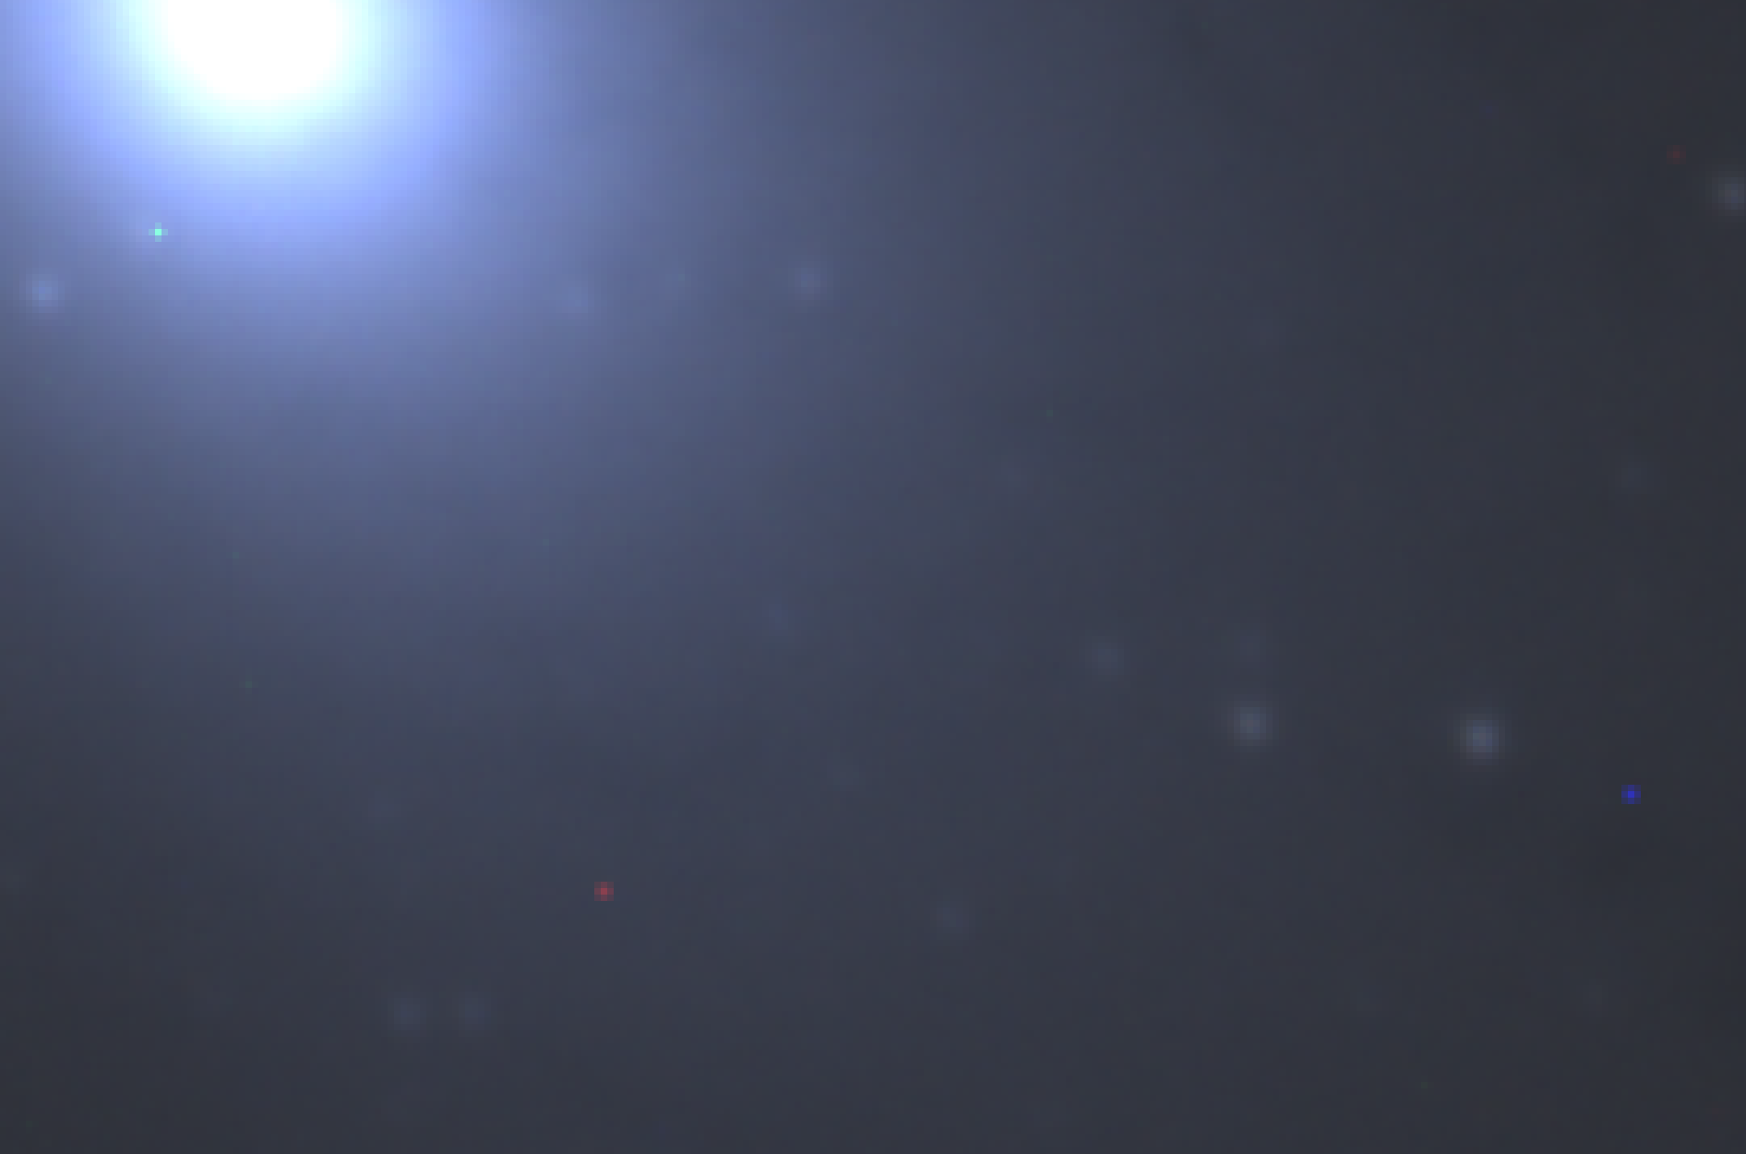
Figure 4-2 After DeBayer process

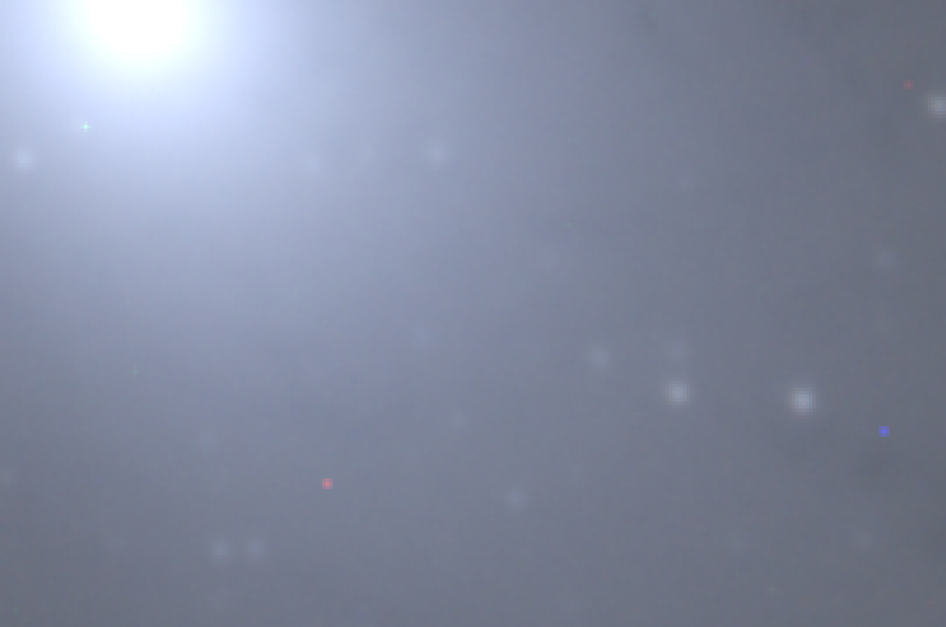
Figure 4-3 DeBayered and Stretched

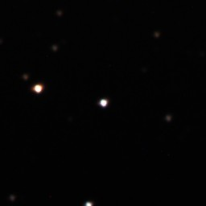
Figure 4-4 256x256 Color Training Image

Data Augmentation
Augmentation artificially multiplies our data by creating modified versions of our existing images during training. This is critical for deep learning on small datasets because it prevents the model from memorizing specific images (overfitting). So we are performing Random shift, random rotation and random zoom.
transform = transforms.Compose([
transforms.ToTensor(),
# --- Augmentations for bad data ---
transforms.RandomAffine(
degrees=15, # Randomly rotate
translate=(0.1, 0.1), # Randomly shift
scale=(0.8, 1.2) # Randomly zoom
),
transforms.RandomHorizontalFlip(),
transforms.RandomVerticalFlip(),
])

Data Normalization
Data Normalization is the process of mathematically rescaling our raw pixel intensity values, which in astronomy can range wildly from 0 to 65,535 into a standardized, small range, typically 0 to 1. This step is mandatory for neural networks because their internal math (gradient descent) becomes unstable and slow when processing large or inconsistent numbers. By normalizing the data, we ensured the model learnt the relative shapes of the stars (the geometry) rather than getting confused by how bright the exposure happened to be, leading to faster and more stable training.
In our workflow, this normalization step is already integrated into the preprocessing and loading pipeline. The stretched star cutouts are rescaled into a 0–1 range using Astropy’s ImageNormalize (scales your stretched images to 0–1), and PyTorch’s ToTensor() (converts your (H, W, C) NumPy array into a PyTorch tensor and automatically scales it to 0–1) preserves this normalized format when converting the images into tensors. As a result, every sample reaches the network with consistent numerical scaling, ensuring stable gradients and efficient learning without requiring an additional explicit normalization step.

Image Standardization
Standardizing to avoid the light pollution, this forces the background to 0 and the star features to vary around 1, regardless of how bright the moon was that night. Image Standardization acts as a statistical equalizer for our dataset by adjusting pixel values so they have a mean of 0 and a standard deviation of 1.

Training data extraction
The next step in the process was identifying the regions of interest by selecting a fixed number of the brightest star points from each image and building a dataset from them. This was essential because it allows the model to focus on the most relevant information while ignoring the vast amount of empty sky and background noise that astronomical images typically contain. Another advantage of working with selected ROIs instead of full images is the significant reduction in preprocessing time, making the overall pipeline much more efficient. We experimented with several methods to extract the most efficient and reliable regions of interest, since high-quality input data directly contributes to developing a strong prediction model.

DAO Star Finder
DAOStarFinder is a class from the photutils library designed to detect stars in astronomical images. It searches for local peaks in intensity that match the shape of a 2D Gaussian function. DAOStarFinder functions as an intelligent filter and locator, identifying high-signal star candidates by scanning Gaussian-shaped intensity peaks that exceed a strict 10-sigma threshold above the background noise. Once these potential targets are located, the script enforces a critical edge margin of 128px to validate the coordinates, automatically discarding any stars found too close to the image boundaries. This ensures that every extracted sample is a complete, perfectly centered square without being cut off by the frame edges, guaranteeing that our neural network trains only on valid, full-context data. This is more efficient method for star extraction, and we used this method after comparing with other methods.

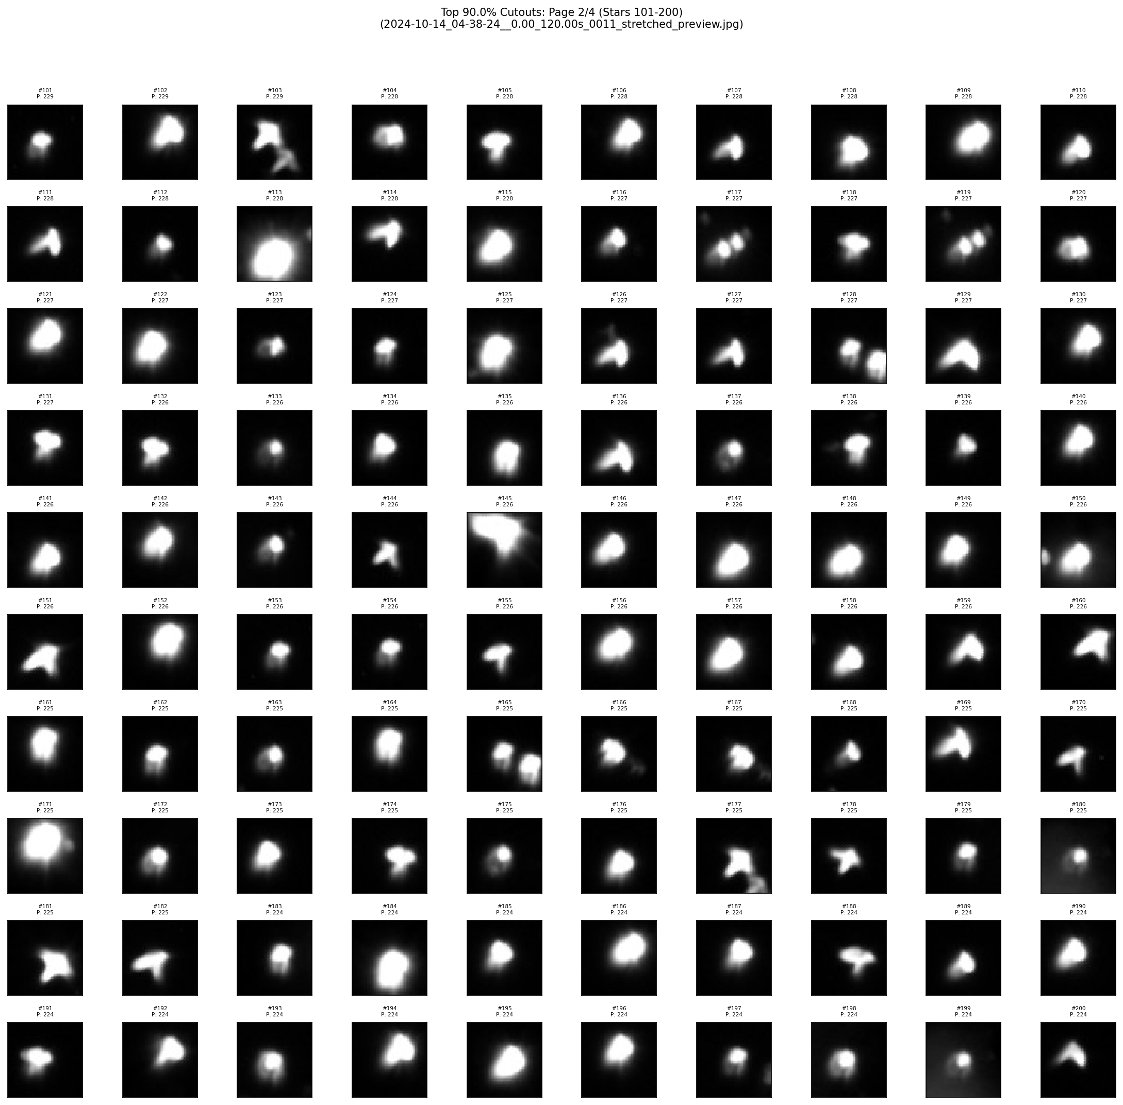
Figure 4-5 DAOStarFinder Results

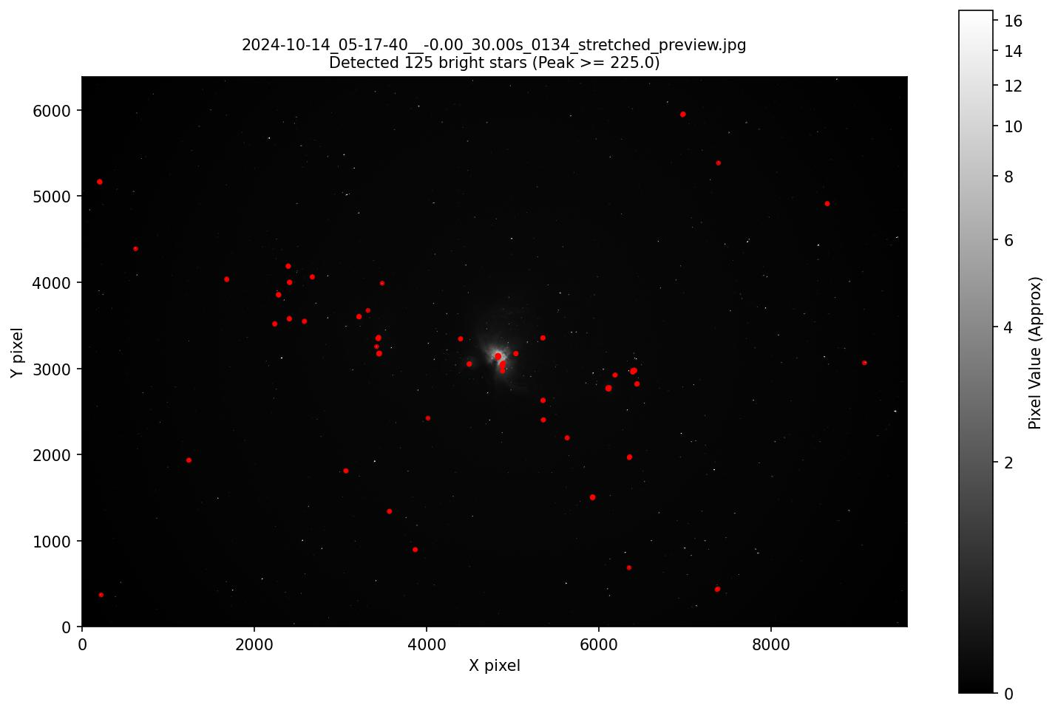
Figure 4-6 DAOStarFinder Locations

YOLO Model
We briefly explored using YOLO as a learned detector for star extraction, since it can localize objects efficiently in a single pass. However, YOLO struggled with the extremely small, point-like nature of stars and often produced inconsistent or misaligned boxes, especially for faint sources in dense fields. It also required significantly more annotated data and training time than our preprocessing pipeline was designed to handle. For these reasons, YOLO was not selected for star extraction.
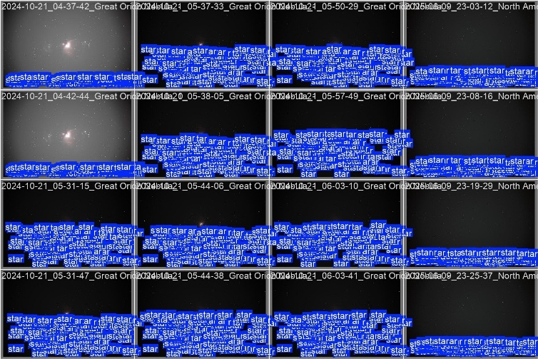
Figure 4-7 Star extraction using YOLO
That said, YOLO remains highly useful for detecting non-stellar structures such as satellite streaks. Its ability to identify elongated or irregular features makes it a strong candidate for future work on automated satellite detection and filtering in astronomical imaging.

NMS+MSER
In this method, we applied the MSER (Maximally Stable Extremal Regions) algorithm on the inverted grayscale image to automatically detect bright star-like blobs and convert their bounding regions into padded square boxes. For each detected region, we calculated a brightness score based on the summed pixel intensities and then applied Non-Maximum Suppression (NMS) to remove overlapping or duplicate detections, leaving only the strongest candidates. From these filtered regions, we selected the top 20 brightest points, visualized the bounding boxes on the full image, and extracted the corresponding cropped patches for dataset formation. However, after exploring this process, we realized that MSER-based selection could not reliably distinguish between stars and bright nebula structures, causing the method to frequently pick high-intensity nebula patches rather than true star points as shown in Figure 4-8 and Figure 4-9, ultimately making this approach less useful for our task.

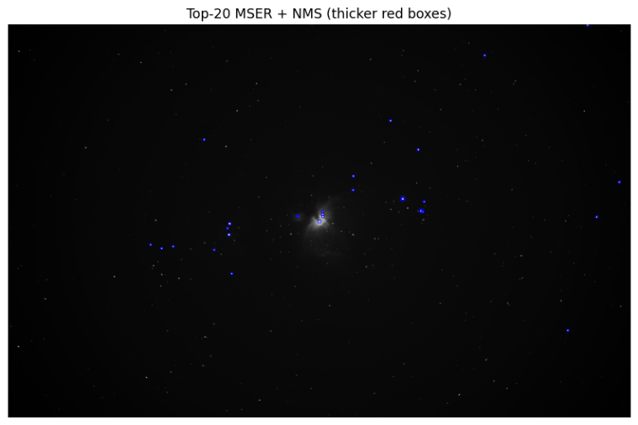
Figure 4-8 Extraction using MSER and NMS extracting regions in nebula
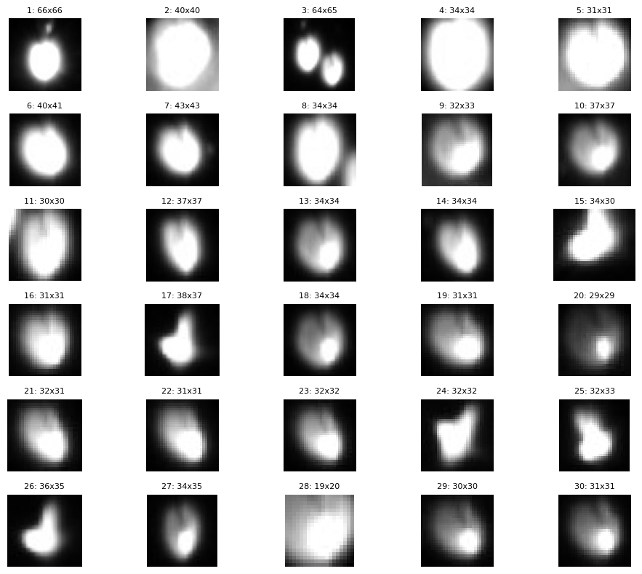
Figure 4-9 Cropped images of stars

Model testing
We attempted to use transfer learning to start with but as we migrated to the monochrome data we found the the pre-trained weights didn’t give good results. We did attempt to use the mean of the 3 channels of color weights in place of the color weights but training from scratch yielded much better results on ResNet-18 and MobileNetV2. The remaining models were only tested from scratch.
Table 4-1 Model Testing Results
After the mid-semester report we ran all the models shown in Table 4-1 against brand new data from a different imaging session. Based on the results we realized that all of the models had a bias towards the “good” class. This indicates the importance of a balanced training for accurate results.
Based on this finding we programmatically applied additional transformations to the other classes to create a balanced dataset. This resulted in much more consistent performance between models. We also leveraged a learning rate decay that halves the learning rate when accuracy stalls for 2 consecutive Epochs and an early stop when accuracy stalls for 6 consecutive Epochs. See results in Table 4-2 and Figure 4-10.
Table 4-2 Model Testing Results

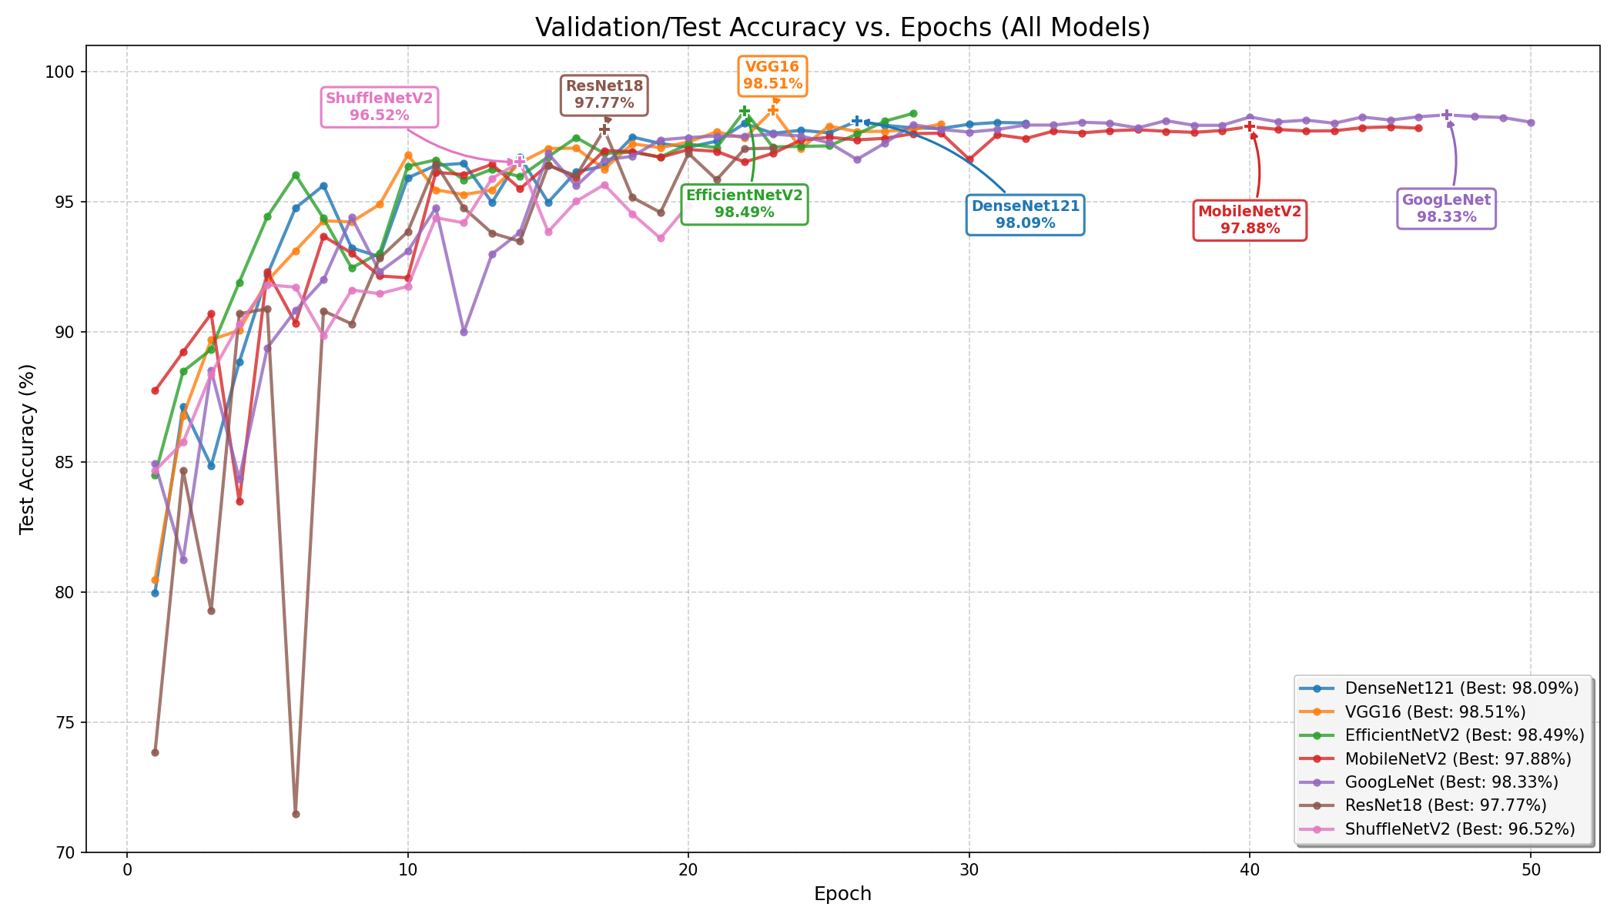
Figure 4-10 Multi-Model results table

Resnet-18
ResNet-18 is an 18-layer convolutional neural network from the ResNet family and is known for being compact and lightweight. Instead of requiring each layer to learn entirely new representations, ResNet-18 uses residual learning, where the network learns the difference (residual) between the input and output of a block. This is enabled through skip connections, which allow gradients to flow more easily and effectively solve the vanishing and exploding gradient problems. ResNet-18 performs well on image classification tasks, particularly when the images have a clear spatial structure. In our case, we evaluated the model in two scenarios, using pretrained weights and training from scratch, and observed that the model trained from scratch outperformed the pretrained version for our specific dataset.

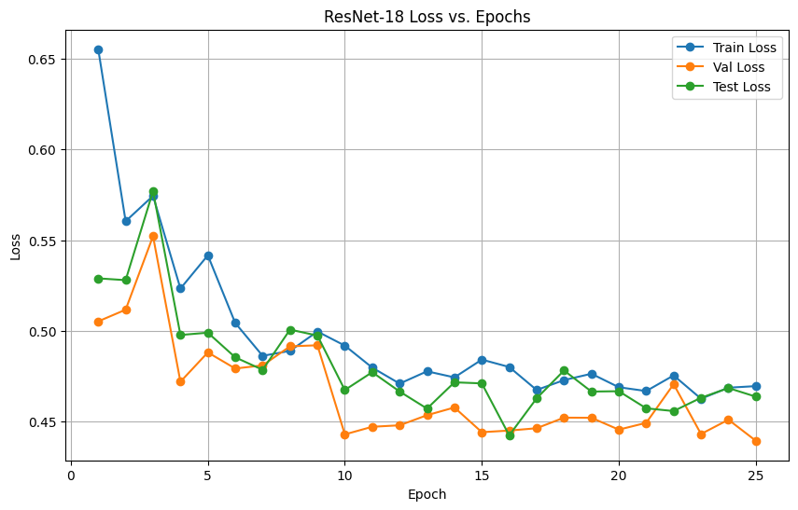
Figure 4-11 Pre-Trained ResNet-18 Loss
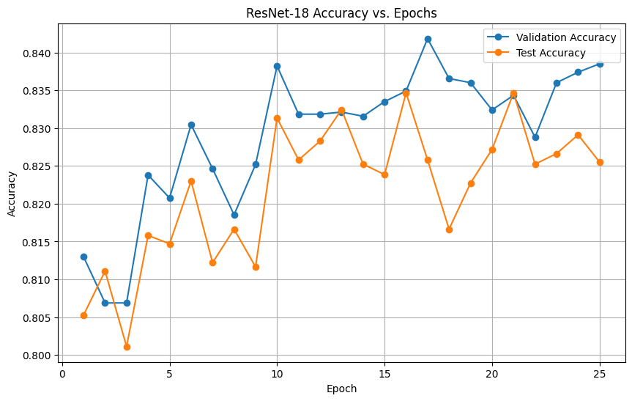
Figure 4-12 Pre-Trained ResNet-18 Accy
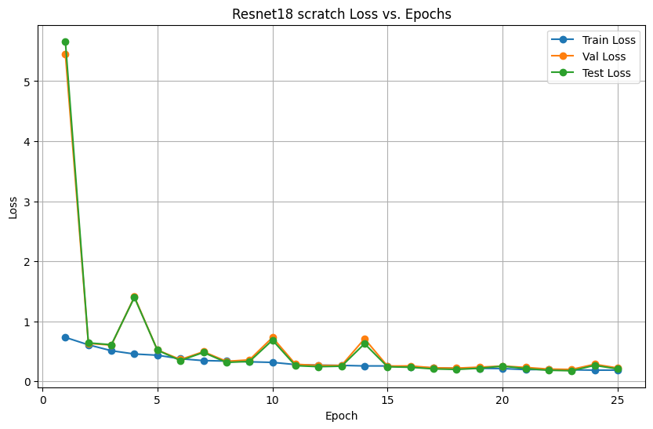
Figure 4-13 Scratch ResNet-18 Loss
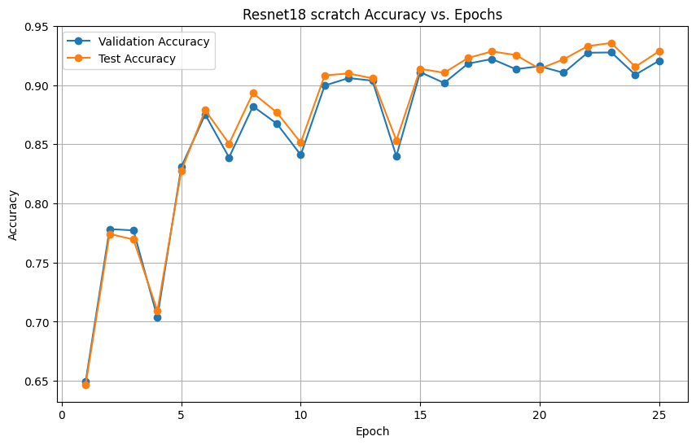
Figure 4-14 Scratch ResNet-18 Accy

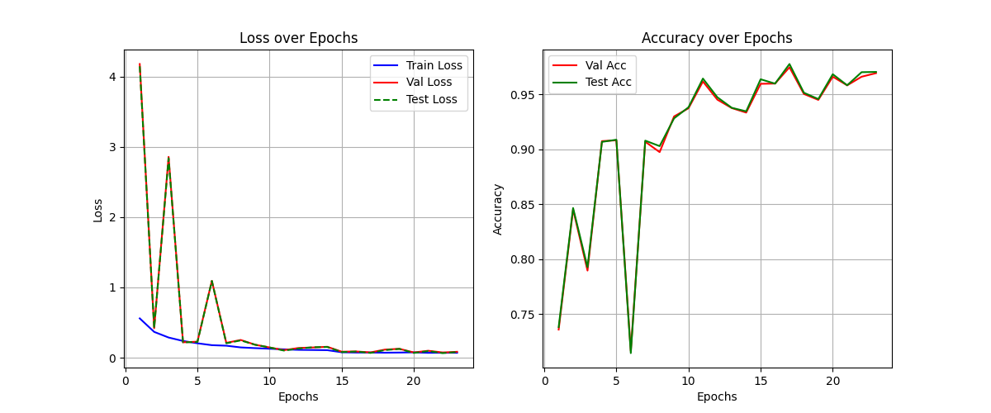
Figure 4-15 ResNet-18 Performance after Dataset Balance

MoileNetV2
MobileNetV2 is a compact convolutional neural network designed for efficient, low-power computer vision applications, particularly on embedded and mobile devices. It significantly reduces computational cost by minimizing the number of parameters, largely through the use of inverted residual blocks that allow features to flow effectively across layers of different depths. MobileNetV2 is widely used for image classification tasks, offering a strong balance between accuracy and efficiency.

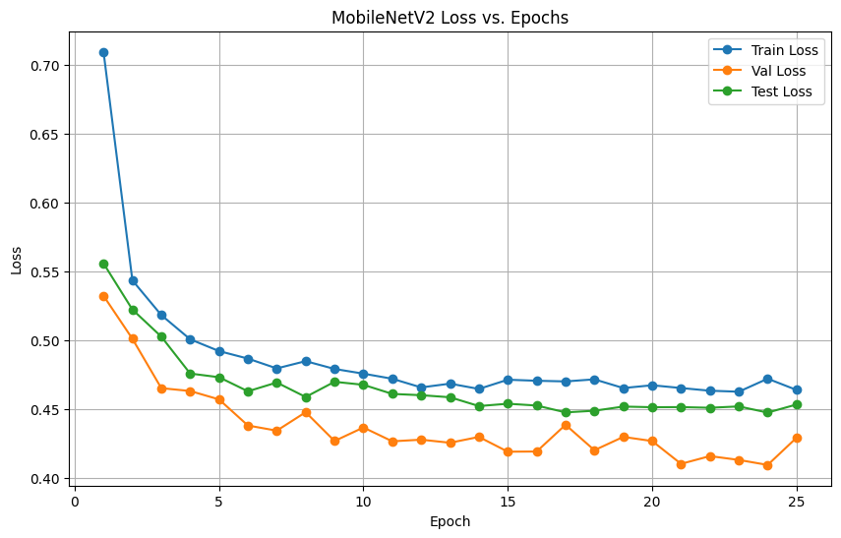
Figure 4-16 Pre-Trained MobileNetV2 Loss
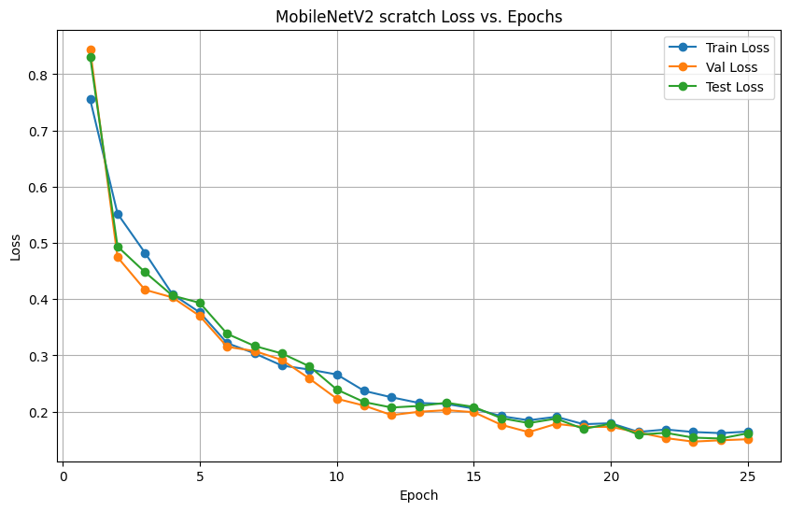
Figure 4-17 Scratch MobileNetV2 Loss
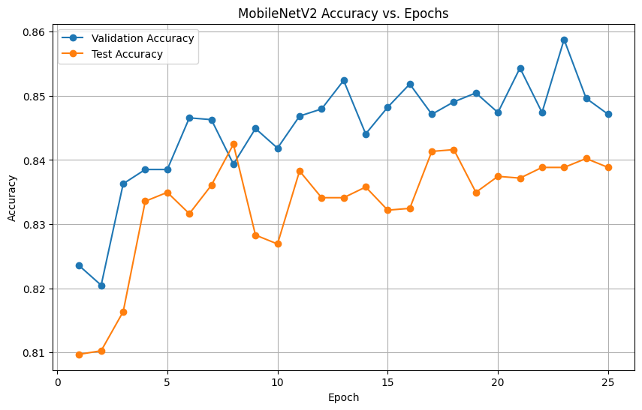
Figure 4-18 Pre-Trained MobileNetV2 Accy
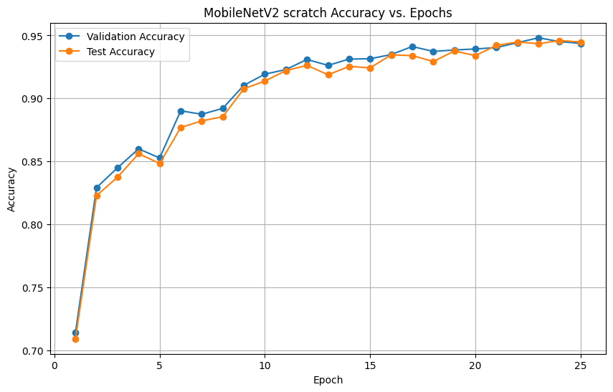
Figure 4-19 Scratch MobileNetV2 Accy

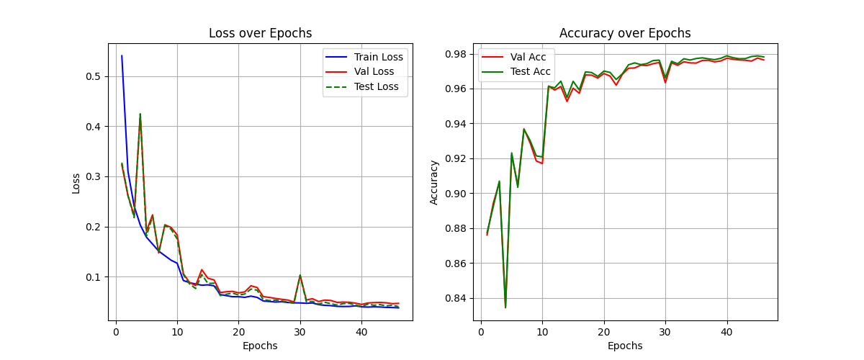
Figure 4-20 MobileNetV2 Performance after Dataset Balance

ShuffleNetV2
ShuffleNet prioritizes computational speed rather than just parameter count, making it ideal to classify stars in real-time on low-power hardware. It achieves this using pointwise group convolutions and channel shuffling. Instead of performing a heavy calculation where every input channel interacts with every output channel, ShuffleNet breaks the data into independent groups to speed up processing, and then "shuffle" the channels to ensure information still flows between groups. This allows it to capture the spatial features of your "focus" or "tracking" errors with a fraction of the floating-point operations (FLOPs) required by a standard custom CNN.

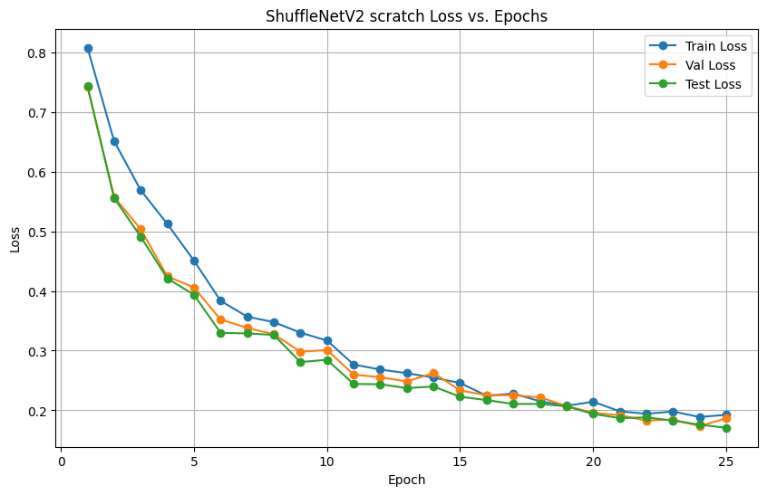
Figure 4-21 Scratch ShuffleNetV2 Loss
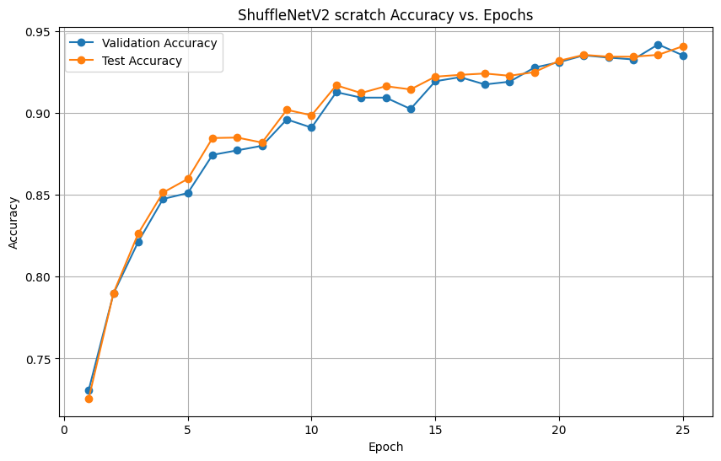
Figure 4-22 Scratch ShuffleNetV2 Accy

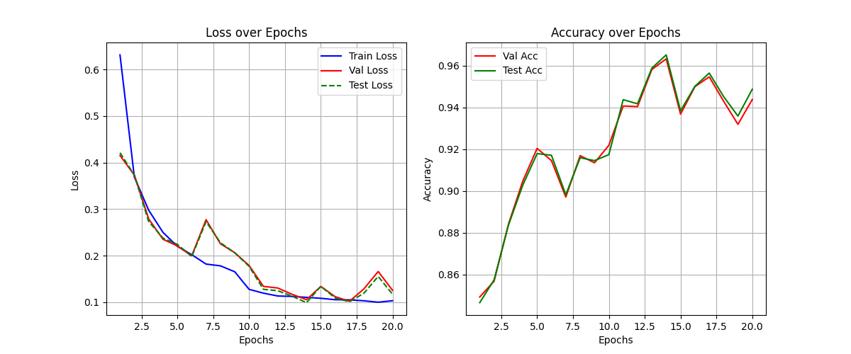
Figure 4-23 ShuffleNetV2 Performance after Dataset Balance

DenseNet-121
DenseNet-121 achieves efficiency through feature reuse via its "dense connectivity" pattern. Unlike standard CNNs where layers only see the output of the immediate previous layer, each layer in a DenseNet block receives inputs from all previous layers. This means the fine-grained details of a star's edge (learned in the very first layers) are preserved and directly accessible by the final classification layers. For our project, this is highly efficient because the model does not need to waste parameters "re-learning" the basic shape of a star at every stage; it simply carries that information forward, allowing for high accuracy with fewer parameters.

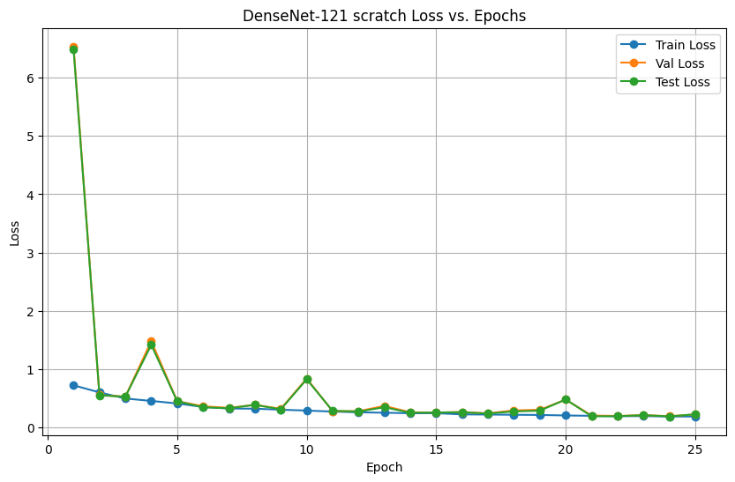
Figure 4-24 Scratch DenseNet-121 Loss
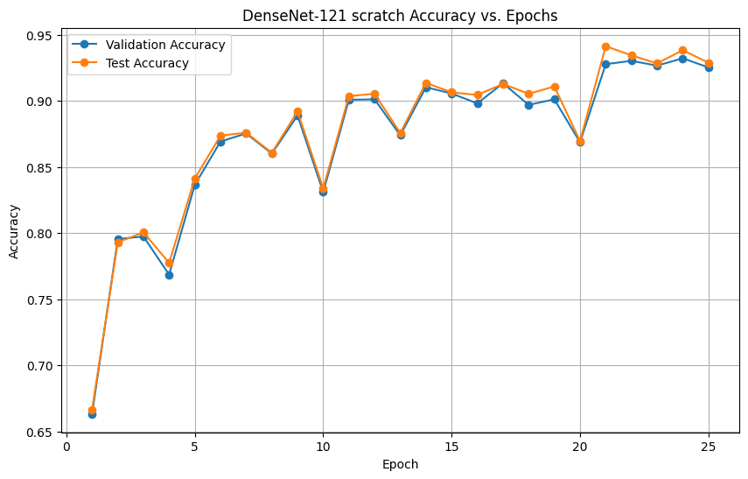
Figure 4-25 Scratch DenseNet-121 Accy

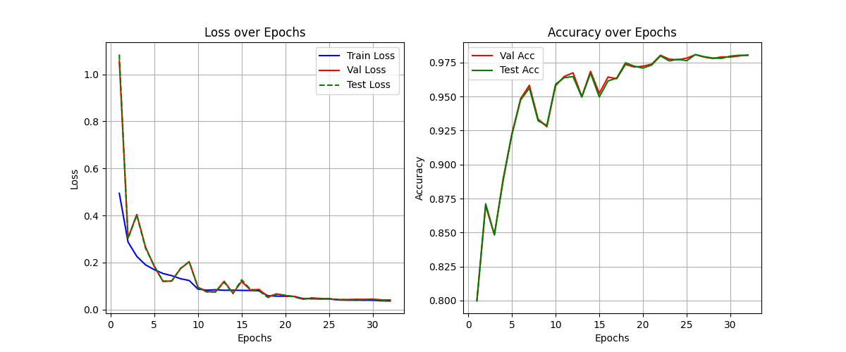
Figure 4-26 DenseNet-121 Performance after Dataset Balance

GoogLeNet
GoogLeNet applies a multi-scale feature extraction strategy through its Inception modules, where each block processes the same input using 1×1, 3×3, and 5×5 convolutions in parallel. This design allows the network to capture both the fine point-like structure of stars and the broader distortions seen in defocus or tracking errors without significantly increasing computational cost. Because information is extracted at multiple receptive fields simultaneously, GoogLeNet can recognize subtle variations in star shape that might be missed by a single-scale architecture. In our project, this property made GoogLeNet particularly effective at distinguishing between the four quality classes, achieving strong accuracy while remaining lightweight and efficient to train from scratch.
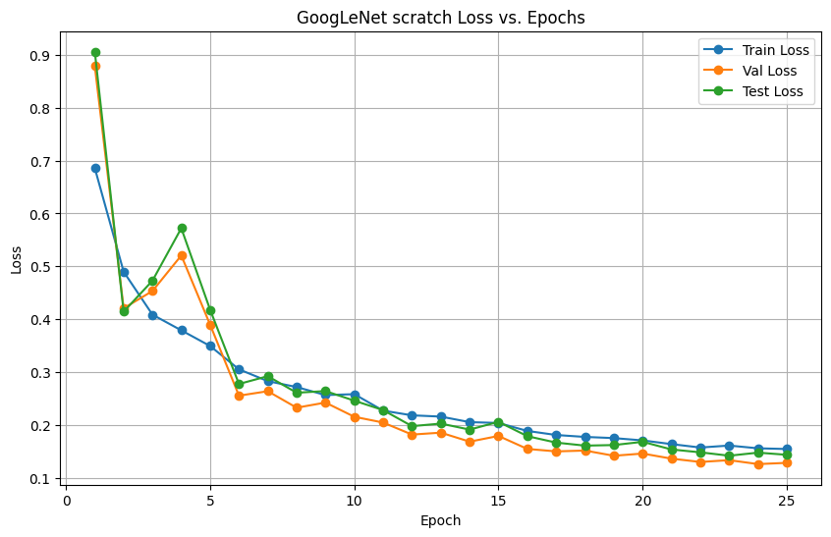
Figure 4-27 Scratch GoogLeNet Loss
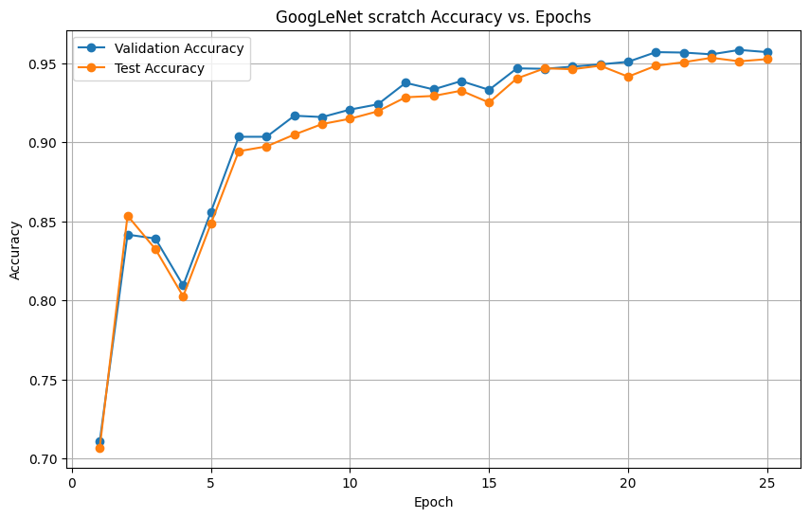
Figure 4-28 Scratch GoogLeNet Accy
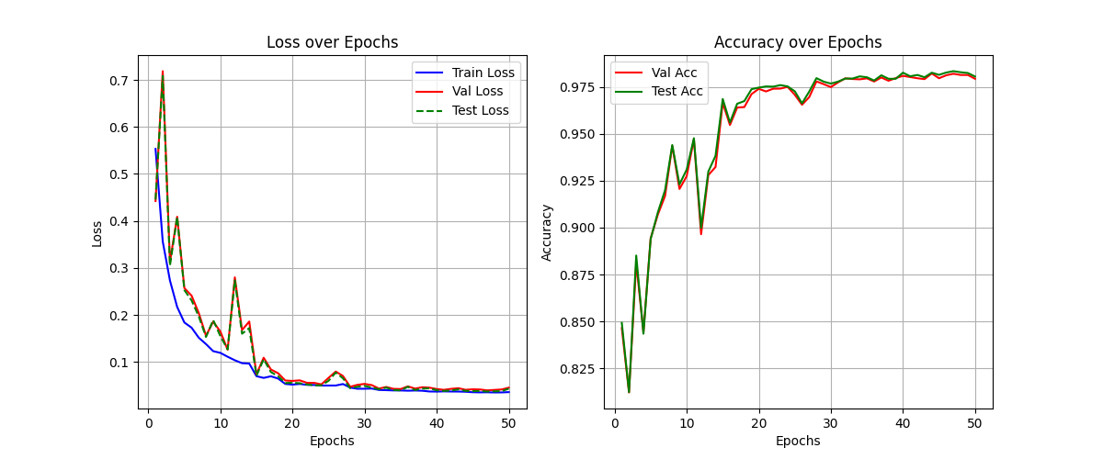
Figure 4-29 GoogLeNet Performance after Dataset Balance

EfficentNetV2
EfficientNetV2 improves efficiency through a combination of fused MBConv layers and compound scaling, allowing the model to balance depth, width, and resolution in a structured way. Its fused blocks enable early layers to capture high-quality spatial detail without the computational overhead typically associated with depthwise convolutions. For star-shape classification, this architecture is advantageous because it extracts fine structural differences such as elongation, softness, or jitter while maintaining fast inference speeds. In our experiments, EfficientNetV2 demonstrated excellent generalization and consistently produced the lowest losses across training, validation, and testing, making it the top-performing model in our evaluation.
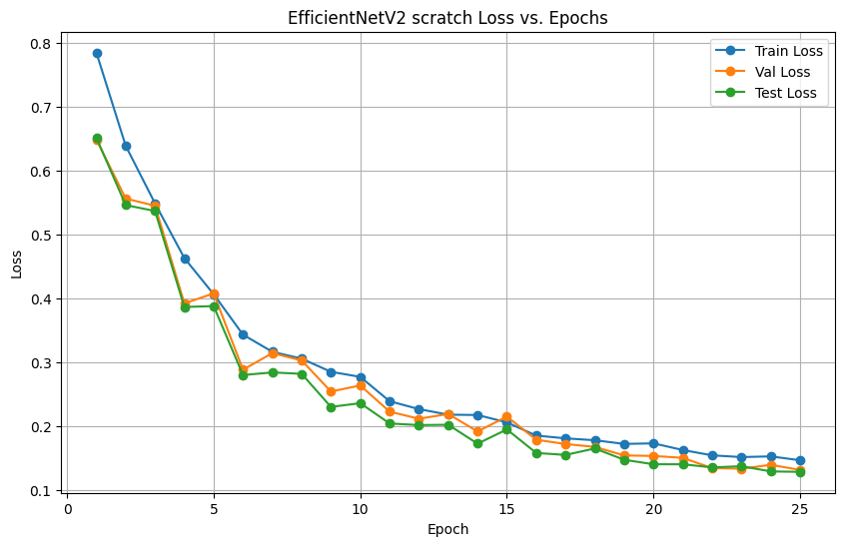
Figure 4-30 Scratch EfficentNetV2 Loss
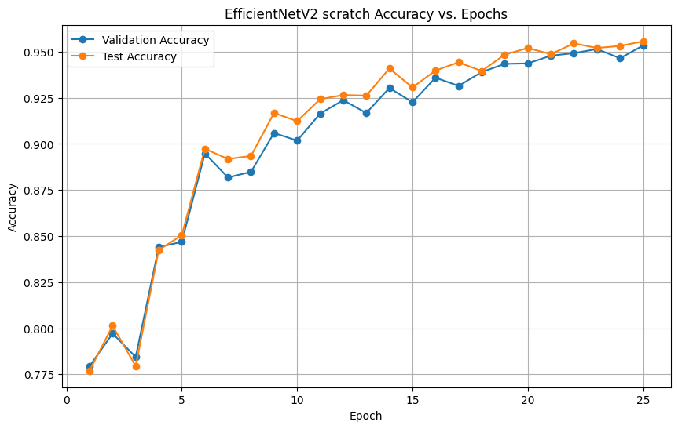
Figure 4-31 Scratch EfficentNetV2 Accy

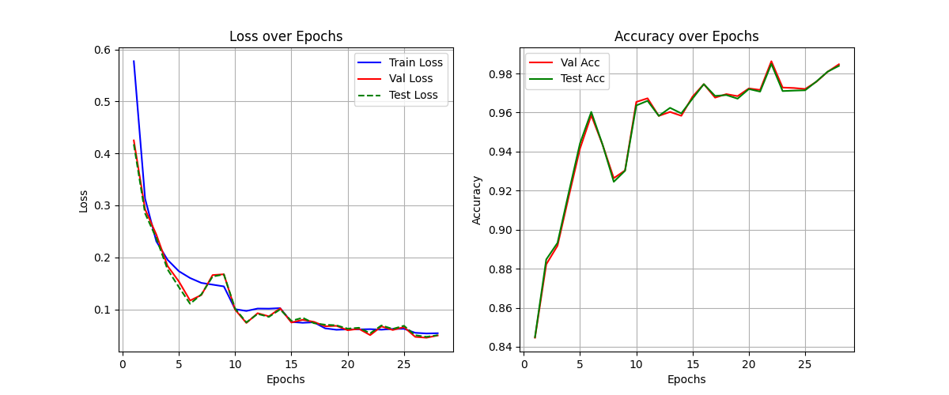
Figure 4-32 EfficentNetV2 Performance after Dataset Balance

VGG16_BN
VGG16_BN uses a deep stack of uniform 3×3 convolutional layers with batch normalization added to stabilize gradients and improve convergence. Its simplicity is a strength because applying the same small kernel repeatedly allows the network to build a hierarchical understanding of local features. This makes it effective at identifying the rounded, symmetric structure of well-focused stars as well as more distorted patterns. Although VGG16_BN contains significantly more parameters than modern architectures, this depth allows it to learn a rich representation of star morphology. In our project, the model performed reliably when trained from scratch, producing competitive accuracy while showing more variability in early epochs due to its larger capacity.
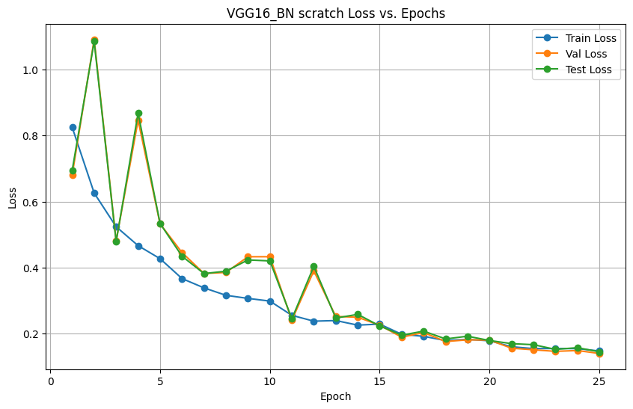
Figure 4-33 Scratch VGG16_BN Loss
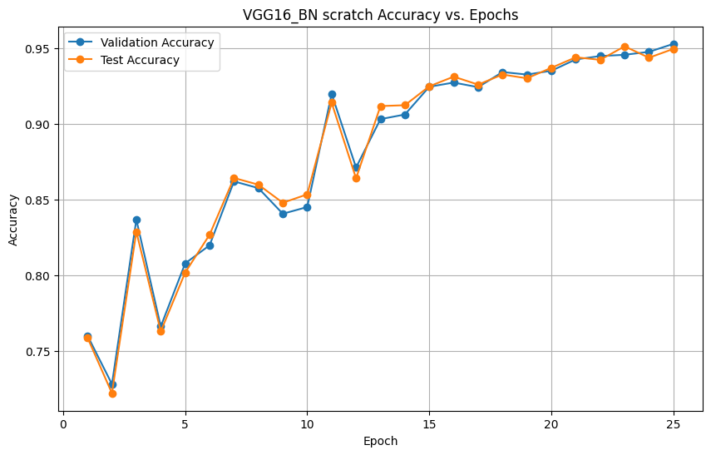
Figure 4-34 Scratch VGG16_BN Accy

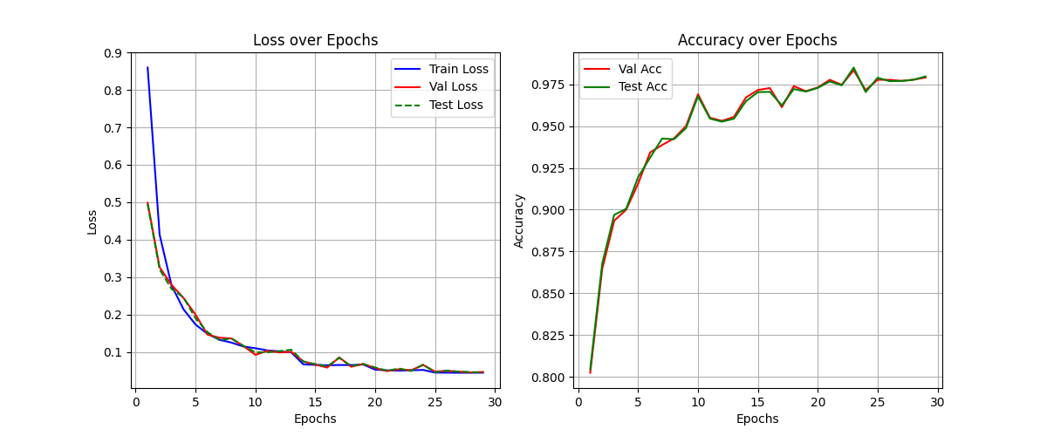
Figure 4-35 VGG16_BN Performance after Dataset Balance

Notable Observations:
- Star extraction methods
  - After comparing the different methods for star extraction, we found that DAO Star Finder is purpose built and is the best option to create our dataset.
  - Hot pixels are bright colored pixels that randomly appear in the digital image. We faced quite some challenges to filter them out. In order to deal with this, we used a roundness-sharpness metrics measurement and blocked the metric beyond a certain range.
  - We had to remove the boundary pixels as things close to edge get cut-off, stopping the model from seeing the full shape thus we fixed a cutout_size/2 from any edge
  - We discussed multiple cutout sizes ranging from 64x64 to 512x512 pixels, but ultimately selected 256x256 since it aligns with ResNet’s preferred input size and provides sufficient context around each star
  - Proper handling of 16-bit image data was critical. We observed that incorrect scaling or casting of raw pixel values could severely degrade model performance, emphasizing the importance of correct normalization during preprocessing.

- Models
  - We compared transfer learning with training the model from scratch and found that scratch training performed significantly better. This is because astrophotography images have characteristics, such as dark noise patterns, 16-bit depth instead of 8-bit RGB, and very low SNR, that are fundamentally different from the natural images used to train models like ResNet-18. As a result, pretrained weights offered little advantage, while training from scratch allowed the model to learn features specific to our domain.
  - VGGnet DenseNet-121 required much smaller batch size to fit in the GPU memory despite being trained on the same data.
  - Class imbalance biased models toward the “good” class, producing misleadingly high accuracy. Balancing the dataset via targeted augmentation of “bad” examples improved classification reliability and decision boundaries, as confirmed through manual inspection.
  - Learning rate decay and early stopping improved training stability and generalization, particularly for deeper architectures, by reducing overfitting.
  - Training stability was improved by tuning batch sizes and memory usage rather than aggressively increasing model depth.
  - The convergence of several distinct architectures to similar performance levels suggests that the current pipeline is robust and well-optimized for the problem domain.

Conclusion and Future Direction:
Over the course of the semester, we learned that robust preprocessing is foundational to reliable astrophotography image classification. Careful star extraction using a purpose-built method such as DAO Star Finder, effective hot pixel filtering through roundness–sharpness metrics, edge-aware cutout selection, and thoughtful choice of cutout size were all shown to be just as critical to model performance as the selection of the neural network architecture itself. We also learned that subtle data handling issues such as improper normalization of 16-bit image data can severely degrade model performance, even when the network architecture itself is sound. Addressing these issues ensured that the models were trained on clean, representative star samples with sufficient spatial context and correct intensity scaling. One of the most important insights was that models trained from scratch consistently outperformed transfer learning approaches. This reinforced our understanding that astrophotography images differ fundamentally from natural image datasets in terms of noise structure, grayscale bit depth, and extremely low signal-to-noise ratios. As a result, pretrained weights offered limited benefit, whereas training from scratch allowed the models to learn features that are truly specific to the astrophotography domain.
After the mid-semester report, all models shown in Table 4-1 were evaluated against brand new data collected from a different imaging session. This evaluation revealed a clear bias across architectures toward predicting the “good” class, which we traced back to an imbalance in the training data, where good-quality images were overrepresented. This observation led to an important learning outcome: dataset balance plays a critical role in preventing misleadingly high accuracy and ensuring meaningful classification behavior. To address this issue, we increased the number of “bad” examples by generating additional data through targeted data augmentation techniques, resulting in a more balanced dataset. This adjustment significantly improved the model’s ability to correctly identify poor-quality images, an improvement that was verified both quantitatively and through manual inspection of predictions. Alongside this change, we introduced a learning rate decay strategy that halves the learning rate when accuracy stalls for two consecutive epochs, as well as early stopping when accuracy stalls for six consecutive epochs. Together, these refinements led to significantly more consistent and stable performance across all models, as shown in Table 4-2 and Figure 4-10.
At this stage, the project has reached a point where multiple architectures demonstrate strong and reliable classification performance. In particular, EfficientNetV2 emerged as the overall champion model, with VGG16, and MobileNetV2 all achieving comparable accuracy and low test loss. Because VGG16 is >500MB model vs ~80MB and ~9MB for our other leading contenders any additional performance was deemed not worth the additional compute resources required to utilize the model. The fact that several distinct architectures converged to similar high performance suggests that the current preprocessing pipeline and training strategy are well aligned with the underlying structure of the data. Overall, the results indicate that the project is in a solid and encouraging state, with classification accuracy exceeding expectations given the challenging nature of astrophotography imagery.
Given where the project stands now, the most natural next step is to move beyond controlled experiments and expose the workflow to broader, real-world testing. Integrating the trained classification model into a user-friendly graphical interface would allow larger astrophotography image libraries to be processed efficiently while enabling manual verification where needed. Opening the tool to the astrophotography community would provide valuable feedback, reveal edge cases not captured in the current dataset, and support iterative refinement of both the dataset and the model. This progression follows directly from the results achieved so far and represents a logical transition from model development to practical, community-driven evaluation and use.
Git repo located here: https://gitlab.oit.duke.edu/tmf48/practicalml

References:
[1] H. Teimoorinia, J. J. Kavelaars, S. D. J. Gwyn, D. Durand, K. Rolston, and A. Ouellette, “Assessment of Astronomical Images Using Combined Machine-learning Models,” Astronomical Journal, vol. 159, no. 4, p. 170, Mar. 2020, doi: 10.3847/1538-3881/ab7938
[2] Li, Juan, et al. "Astronomical Image Quality Assessment Based on Deep Learning for Resource-constrained Environments." Publications of the Astronomical Society of the Pacific 137.3 (2025): 034502.

